Rəvan Muradzadə
I have done.
- I have done.
- I have done.
- Virtualization is a technique where we can have multiple operating systems in one hardware. So, without it, for each operating system we need to purchase different hardware, and of course that is very expensive. Its purpose is better performance, and isolation of operating systems. By using virtualization, we just need to download hypervisor tools like WmWare Workstation Pro and have multiple guest operating systems in one hardware. Virtualization lets cloud providers (AWS, Azure, GCP) host thousands of VMs on fewer physical machines.
- We already know that Linux itself is just a kernel, not operating system. To make it usable we need to have operating system on it. So, in that case linux distributions come to mind. They are operating systems built around Linux kernel, with various software and tools. There are a lot of distros. From user friendly ones like ubuntu, linux mint, pop os to more advanced ones like Arch or Gentoo linux. There is Turkish distro named Pardus.
It is easy to create a new distro. Even if you have enough knowledge, you can create a new one. However, there is a requirement that you must share its source code. Below you can see Ubuntu based linux distros:
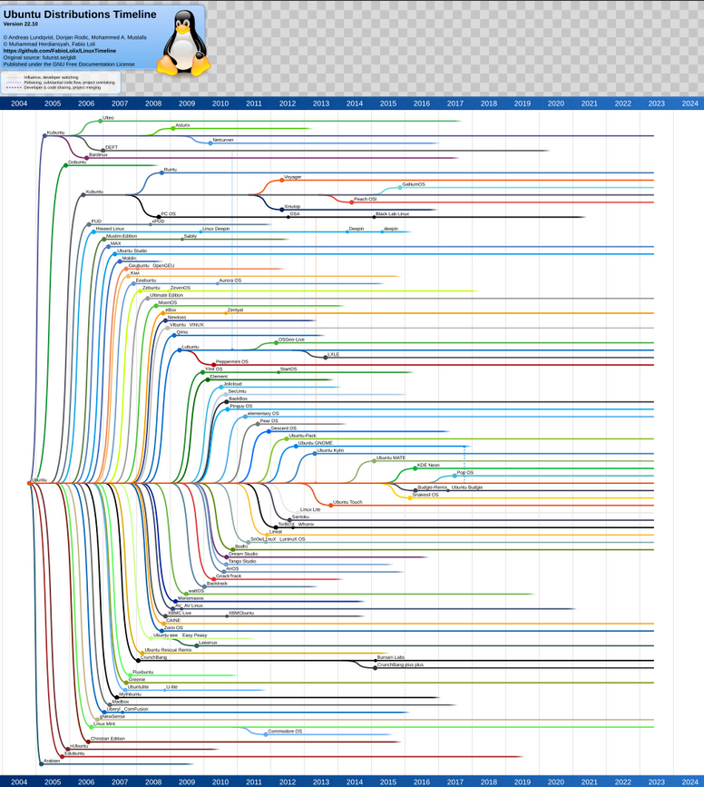

6) Red Hat is a company that makes Red Hat Enterprise Linux (RHEL), an enterprise-level distribution, using the Linux kernel. Red Hat has some important differences from a lot of other distributions (including Ubuntu, Debian, and Arch) in its focus. Red Hat focuses on corporate infrastructure, enterprise settings, stability, long-term maintenance, and security enhancements. Businesses use RHEL for servers, data centers, telecom networks, and banking. Deals that are reliable and supportive are more significant than "latest features."

Furthermore, Red Hat's creation of an open-source business model makes it better. Businesses must pay for official maintenance, updates, support, and certification even if the program is free.

Built on the Red Hat Enterprise Linux source code, CentOS a free Linux distribution with community support. The RHEL source code is freely available for anybody to use, rebuild, and distribute after Red Hat trademarks have been removed. CentOS did just that in the beginning. Without Red Hat's branding and paid maintenance, it was essentially RHEL.

Timeline of the relationship:

CentOS was entirely community-driven at first.
The CentOS project was formally taken up by Red Hat in 2014.
Red Hat modified the strategy and turned its attention on CentOS Stream in 2020.
CentOS Stream is not the same. RHEL has not been directly rebuilt. Rather, it is situated in the development pipeline between Fedora and RHEL:

Fedora -> RHEL → CentOS Stream

7) Open source means software whose source code is accessible and open to the public, allowing people to be able to see, check, alter, and distribute it in accordance with certain licensing guidelines.

Open source means freedom but does not always show cost-free. The main freedoms are:
* The ability to use the application freely
* The ability to check and examine how it functions
* The ability to change it
* The ability to share its copies
The General Public License (GPL), developed by Richard Stallman, is a main and important open-source license. Linus Torvalds' Linux kernel is made available under the GPL. Thus some companies like Red Hat can use, alter, and share Linux in a legal way, but they also need to abide by the licensing guidelines.
Collaboration is now possible, easy, very comfortable with the usage of open source. Contributions, code reviews and checks, bug fixes, and security enhancements are all possible with thousands of developers worldwide. Linux is usually trusted in corporate systems because of this.
8) Kernel is the core part of an operating system. It talks directly to the hardware (CPU, RAM, disk, devices) and manages process, memory and service calls.
An operating system (OS) is bigger: It includes kernel plus system libraries, utilities, package managers, shells, and user tools.
